TRINITY LUTHERAN CHURCH (L.C.M.S.)
1100 E. MESA AVE. P.O. BOX 2860
GALLUP, NM 87305-2860
OFFICE: (505) 863-3375
tlcgallup@gmail.com
Web: trinitygallup.org

DAY OF THANKSGIVING EVE
Who’s the Fool?
November 26, 2025

AS WE GATHER: Did you give thanks for your last meal? Most people—even Christians—often “forget” to give thanks. When we do not give thanks, we are like the rich fool of the parable, thinking it was his work that brought the grain, when in fact it was God who gave it to Him. When we do not give thanks, we become fools, forgetting who gave us what we have and all we are. Have you been foolish? That is what Jesus calls the rich man. Give thanks always—that is the advice of Paul. Above all, give thanks for the cross and the empty tomb, which opens heaven to us.

PRAYER BEFORE WORSHIP: O Lord, my creator, redeemer, and comforter, as I come to worship you in spirit and in truth, I humbly pray that You would open my heart to the preaching of Your word so that I may repent of my sins, believe in Jesus Christ as my only Savior, and grow in grace and holiness. Hear me for the sake of his name. Amen.

HOLY COMMUNION: The Lord’s Supper is celebrated at this congregation in the confession and glad confidence that, as he says, our Lord gives into our mouths not only bread and wine but - his very body and blood to eat and to drink for the forgiveness of sins and to strengthen our union with Him and with one another. Our Lord invites to His table those who trust His words, repent of all sin, and set aside any refusal to forgive and love as he forgives and loves us, that they may show forth His death until He comes.

PRAYER REQUEST CARDS: In the pew racks are request cards for prayers. If you have a special request please fill out this card and see that the Pastor gets it before worship or give to the ushers during the offering.

WELCOME
LIGHTING OF THE CANDLES
PRELUDE “New Testament Canticle” (31/75)
(From A Service of Prayer and Preaching, Page 266 in hymnal)

PREPARATION

HYMN “Come, Ye Thankful People, Come” [LSB 892] (26/20)

1 Come, ye thankful people, come;
Raise the song of harvest home.
All be safely gathered in
Ere the winter storms begin;
God, our maker, doth provide
For our wants to be supplied.
Come to God’s own temple, come;
Raise the song of harvest home.

2 All the world is God’s own field,
Fruit unto His praise to yield;
Wheat and tares together sown,
Unto joy or sorrow grown.
First the blade and then the ear,
Then the full corn shall appear.
Lord of harvest, grant that we
Wholesome grain and pure may be.

3 For the Lord, our God, shall come
And shall take His harvest home,
From His field shall in that day
All offenses purge away,
Give His angels charge at last
In the fire the tares to cast,
But the fruitful ears to store
In His garner evermore.

4 Even so, Lord, quickly come
To Thy final harvest home;
Gather Thou Thy people in,
Free from sorrow, free from sin,
There, forever purified,
In Thy garner to abide:
Come with all Thine angels, come,
Raise the glorious harvest home.
Text: Henry Alford, 1810–71, alt.
Text: Public domain

INVOCATION

Pastor: In the name of the Father,
People: who created this world and each of us, a reason to give thanks;
Pastor: and of the Son,
People: our ultimate reason for giving thanks because through His love and sacrifice on the cross we are saved;
Pastor: and of the Holy Spirit,
People: who calls, gathers, and enlightens us in the one true faith in Jesus. Amen.

OPENING SENTENCES Psalm 136:1–4

Pastor: Give thanks to the Lord, for He is good,
People: for His steadfast love endures forever.

Pastor: Give thanks to the God of gods,
People: for His steadfast love endures forever.

Pastor: Give thanks to the Lord of lords,
People: for His steadfast love endures forever;

Pastor: to Him who alone does great wonders,
People: for His steadfast love endures forever.

CONFESSION AND ABSOLUTION Psalm 14:1; Romans 3:12; Psalm 136:1

Pastor: The fool says in his heart,
People: “There is no God.” They are corrupt, they do abominable deeds, there is none who does good.

Pastor: We want to think it is other people David refers to in this verse. Yet Paul puts us all in the same category when he writes to the Romans,
People: “All have turned aside; together they have become worthless; no one does good, not even one.” Forgive us, Lord, for the sins we have committed in thought, word, and deed. We deserve Your punishment, both now and for eternity.

Pastor: I have the best news for you as we celebrate and give thanks to God for all He has done this year. He has given us the greatest thing to be thankful for today—the forgiveness of all our sins. As a called and ordained servant of Christ, I forgive you all your sins in the name of the Father and of the Son and of the Holy Spirit.
People: “Give thanks to the Lord, for He is good, for His steadfast love endures forever.” Amen.
(Passing of the Peace)
WORD

INTROIT Psalm 104:24, 27–28, 30; antiphon: v. 33

Leader: I will sing to the Lord as long as I live;
People: I will sing praise to my God while I have being.

Leader: O Lord, how manifold are Your works! In wisdom have You made them all;
People: the earth is full of Your creatures.

Leader: These all look to You,
People: to give them their food in due season.

Leader: When You give it to them, they gather it up;
People: when You open Your hand, they are filled with good things.

Leader: When You send forth Your Spirit, they are created,
People: and You renew the face of the ground.
Glory be to the Father and to the Son
and to the Holy Spirit;
as it was in the beginning,
is now, and will be forever. Amen.

Leader: I will sing to the Lord as long as I live;
People: I will sing praise to my God while I have being.

KYRIE

Leader: In peace, let us pray to the Lord;
People: Lord, have mercy.

Leader: For thanksgiving for all that comes from above, especially our salvation, let us pray to the Lord;
People: Lord, have mercy.

Leader: For thanksgiving for all that You have created, and for the well-being of the church of God, let us pray to the Lord;
People: Lord, have mercy.

Leader: For thanksgiving for all, and that you would bring unity and peace to Your people, let us pray to the Lord;
People: Lord, have mercy.

Leader: In thanksgiving for this holy house and all who offer You their worship, thanks, and praise, let us pray to the Lord;
People: Lord, have mercy.

Leader: Help, save, comfort, and defend us, gracious Lord.
People: Lord, have mercy.

HYMN OF PRAISE “Praise and Thanksgiving” [LSB 789] (22/9)

1 Praise and thanksgiving,
Father, we offer
For all things living,
Created good:
Harvest of sown fields,
Fruits of the orchard,
Hay from the mown fields,
Blossom and wood.

2 Bless, Lord, the labor
We bring to serve You
That with our neighbor
We may be fed.
Sowing or tilling,
We would work with You,
Harvesting, milling
For daily bread.

3 Father, providing
Food for Your children,
By Your wise guiding
Teach us to share
One with another,
So that, rejoicing
With us, all others
May know Your care.
Text: Albert F. Bayly, 1901–84
Text: © 1987 Oxford University Press. Used by permission: LSB Hymn License no. 110004005

SALUTATION

Leader: The Lord be with you.
People: And also with you.

PRAYER OF THE DAY

Leader: Let us pray.
Almighty God, we thank You for all the mercies You have shown to us. You give us food and drink, a place we can call home, and most importantly, the sacrifice of Your Son on the cross to give us forgiveness, life, and salvation through His atoning death and resurrection, which conquered death and the grave forever. Help us not to be fools, that we instead give You thanks on this day and every day. We pray this through Jesus Christ, our Lord, who lives and reigns with You and the Holy Spirit, one God, now and forever.
People: Amen.

We Praise God for Sustaining Life in and through His Word

The nation resounds with thanksgiving for the earth’s bountiful harvest, crops of wheat and grains, all beneath the canopy of God’s almighty care. But “man does not live by bread alone, but man lives by every word that comes from the mouth of the Lord” (Deut. 8:3). The Church is the vessel through which the Word of God penetrates the world with its Law and Gospel. It is this divine Word that proclaims Jesus as the sole source of life, health and wholeness. It is Jesus who heals lepers with His Word: “Go and show yourselves to the priests” (Luke 17:14). Of the 10 cleansed, only one expresses thanksgiving to Jesus. But true gratitude proceeds from a heart sustained by faith. Jesus bids this one Samaritan to “rise and go your way; your faith has made you well” (Luke 17:19). So also, we are sent from the Divine Service, bolstered in our faith by baptismal and Eucharist blessing to be thankful in our circumstances of plenty and hunger, abundance and need (Phil. 4:6–20).

OLD TESTAMENT READING Deuteronomy 26:1–11 (God’s people celebrated the first of the harvest, confessing who it was that gave them the harvest.)

1“When you come into the land that the Lord your God is giving you for an inheritance and have taken possession of it and live in it, 2you shall take some of the first of all the fruit of the ground, which you harvest from your land that the Lord your God is giving you, and you shall put it in a basket, and you shall go to the place that the Lord your God will choose, to make his name to dwell there. 3And you shall go to the priest who is in office at that time and say to him, ‘I declare today to the Lord your God that I have come into the land that the Lord swore to our fathers to give us.’ 4Then the priest shall take the basket from your hand and set it down before the altar of the Lord your God.
5“And you shall make response before the Lord your God, ‘A wandering Aramean was my father. And he went down into Egypt and sojourned there, few in number, and there he became a nation, great, mighty, and populous. 6And the Egyptians treated us harshly and humiliated us and laid on us hard labor. 7Then we cried to the Lord, the God of our fathers, and the Lord heard our voice and saw our affliction, our toil, and our oppression. 8And the Lord brought us out of Egypt with a mighty hand and an outstretched arm, with great deeds of terror, with signs and wonders. 9And he brought us into this place and gave us this land, a land flowing with milk and honey. 10And behold, now I bring the first of the fruit of the ground, which you, O Lord, have given me.’ And you shall set it down before the Lord your God and worship before the Lord your God. 11And you shall rejoice in all the good that the Lord your God has given to you and to your house, you, and the Levite, and the sojourner who is among you.”

Lector: This is the Word of the Lord.
People: Thanks be to God.

GRADUAL Psalm 34:8; 147:9, 11

Leader: Taste and see that the Lord is good! Blessèd is the man who takes refuge in Him!
People: He gives to the beasts their food, and to the young ravens that cry.

Leader: The Lord takes pleasure in those who fear Him,
People: in those who hope in His steadfast love.

EPISTLE Philippians 4:6–20 (“Let your requests be made known to God.”)

6Do not be anxious about anything, but in everything by prayer and supplication with thanksgiving let your requests be made known to God. 7And the peace of God, which surpasses all understanding, will guard your hearts and your minds in Christ Jesus.
8Finally, brothers, whatever is true, whatever is honorable, whatever is just, whatever is pure, whatever is lovely, whatever is commendable, if there is any excellence, if there is anything worthy of praise, think about these things. 9What you have learned and received and heard and seen in me—practice these things, and the God of peace will be with you.
10I rejoiced in the Lord greatly that now at length you have revived your concern for me. You were indeed concerned for me, but you had no opportunity. 11Not that I am speaking of being in need, for I have learned in whatever situation I am to be content. 12I know how to be brought low, and I know how to abound. In any and every circumstance, I have learned the secret of facing plenty and hunger, abundance and need. 13I can do all things through him who strengthens me.
14Yet it was kind of you to share my trouble. 15And you Philippians yourselves know that in the beginning of the gospel, when I left Macedonia, no church entered into partnership with me in giving and receiving, except you only. 16Even in Thessalonica you sent me help for my needs once and again. 17Not that I seek the gift, but I seek the fruit that increases to your credit. 18I have received full payment, and more. I am well supplied, having received from Epaphroditus the gifts you sent, a fragrant offering, a sacrifice acceptable and pleasing to God. 19And my God will supply every need of yours according to his riches in glory in Christ Jesus. 20To our God and Father be glory forever and ever. Amen.

Lector: This is the Word of the Lord.
People: Thanks be to God.

VERSE Psalm 136:1

Pastor: Alleluia. Give thanks to the Lord, for He is good,
People: for His steadfast love endures forever. Alleluia.

HOLY GOSPEL Luke 12:13–21 (A rich man becomes a fool because he does not see God as the reason to give thanks.)

Pastor: The Holy Gospel according to St. Luke, the twelfth chapter.
People: Glory to You, O Lord.

(The Gospel is read.)

13Someone in the crowd said to [Jesus], “Teacher, tell my brother to divide the inheritance with me.” 14But he said to him, “Man, who made me a judge or arbitrator over you?” 15And he said to them, “Take care, and be on your guard against all covetousness, for one’s life does not consist in the abundance of his possessions.” 16And he told them a parable, saying, “The land of a rich man produced plentifully, 17and he thought to himself, ‘What shall I do, for I have nowhere to store my crops?’ 18And he said, ‘I will do this: I will tear down my barns and build larger ones, and there I will store all my grain and my goods. 19And I will say to my soul, Soul, you have ample goods laid up for many years; relax, eat, drink, be merry.’ 20But God said to him, ‘Fool! This night your soul is required of you, and the things you have prepared, whose will they be?’ 21So is the one who lays up treasure for himself and is not rich toward God.”

Pastor: This is the Gospel of the Lord.
People: Praise to You, O Christ.

HYMN OF THE DAY “Sing to the Lord of Harvest” [LSB 893] (26/21)

1 Sing to the Lord of harvest,
Sing songs of love and praise;
With joyful hearts and voices
Your alleluias raise.
By Him the rolling seasons
In fruitful order move;
Sing to the Lord of harvest
A joyous song of love.

2 God makes the clouds rain goodness,
The deserts bloom and spring,
The hills leap up in gladness,
The valleys laugh and sing.
God fills them with His fullness,
All things with large increase;
He crowns the year with blessing,
With plenty and with peace.

3 Bring to this sacred altar
The gifts His goodness gave,
The golden sheaves of harvest,
The souls Christ died to save.
Your hearts lay down before Him
When at His feet you fall,
And with your lives adore Him
Who gave His life for all.
Text: John S. B. Monsell, 1811–75, alt.
Text: Public domain

SERMON
Text: Philippians 4:6-20
Theme: “What Are We Thankful For?”

CREED “Christ, the Word of God Incarnate” [stanza 6, LSB 540] (11/2)

6 Christ, the Alpha and Omega,
Christ, the firstborn from the dead,
Christ, the life and resurrection,
Christ, the Church’s glorious head:
Praise and thanks and adoration
And unending worship be
To the Father and the Spirit
And to You eternally.
Text: Steven P. Mueller, 1964
Text: © 2001 Steven P. Mueller. Used by permission: LSB Hymn License no. 110004005

OFFERING

PRAYER OF THE CHURCH

Leader: With great thanksgiving for all God has given us, we pray for the whole people of God in Christ Jesus and all people according to their needs.
People: We come before the Lord with thankful hearts for all He has done. Lord, hear our prayer.

Leader: Almighty God, we come before You on this great day of Thanksgiving, confessing that You have given us all we have,
People: yet we often foolishly think what we have is of our doing. Forgive us for our foolishness. Lord, hear our prayer.

Special Intercessions
(Let us pray to the Lord; Lord, have mercy)

Leader: We recall that You have called us in Scripture to pray for kings and all in authority that we might live peaceful lives.
People: We lift up every ruler in every land; especially this day, we lift up our President, Congress, and all government officials. Guide all by Your Holy Spirit to accomplish Your will on this earth, that Your kingdom may truly come. Lord, hear our prayer.

Leader: We are also reminded by Your Word to pray for those who are persecuted.
People: We ask that You would be with them in their hour of trial; strengthen their faith and remind them of their great reward. Lord, hear our prayer.

Leader: Each year, Your people of old would recall who they were because of Your blessings.
People: We, like them, are nobody apart from You. Through the cross and empty tomb, You make us Yours by faith, members of Your family, for which we give You thanks. Lord, hear our prayer.

Leader: Your Word calls us to remember the poor and those in need.
People: By Your Holy Spirit, open our eyes that we may see those who are poor and in need that we can serve them. Lord, hear our prayer.

Leader: Lord Jesus Christ, You have sent Your Holy Spirit into our hearts, by which we have believed Your Word and are members of Your kingdom,
People: but we know there are those who do not believe in You. Use us by Your Spirit, according to Your will, that these ripe fields may bring a great harvest for Your glory. Lord, hear our prayer.

Leader: We lift these and all the prayers of our hearts before Your throne, almighty God.
People: We pray in the name of Jesus, who with You and the Holy Spirit is one God, now and forever. Amen.

SACRAMENT

PREFACE 2 Timothy 4:22

Pastor: The Lord be with you.
People: And also with you.

Pastor: Lift up your hearts.
People: We lift them to the Lord.

Pastor: Let us give thanks to the Lord our God.
People: It is right to give Him thanks and praise.

PROPER PREFACE

Pastor: It is truly good, right, and salutary that we should at all times and in all places give thanks to You, holy Lord, almighty Father, everlasting God, through Jesus Christ, our Lord, who on this day overcame death and the grave and by His glorious resurrection opened to us the way of everlasting life. Therefore with angels and archangels and with all the company of heaven we laud and magnify Your glorious name, evermore praising You and saying:

SANCTUS (p. 208 in hymnal) (A/88)

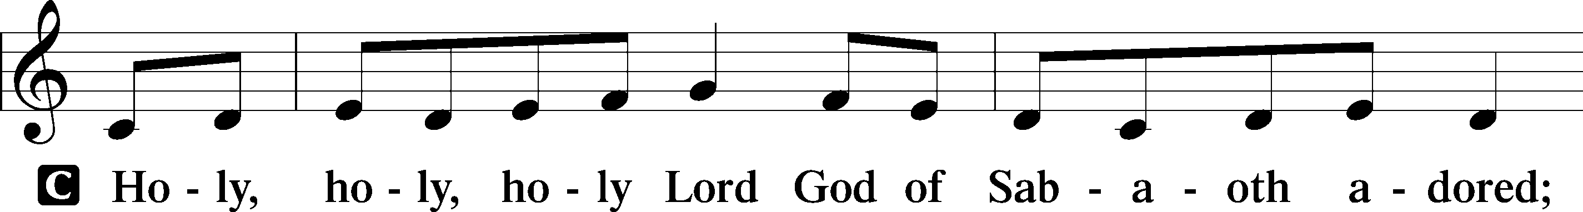
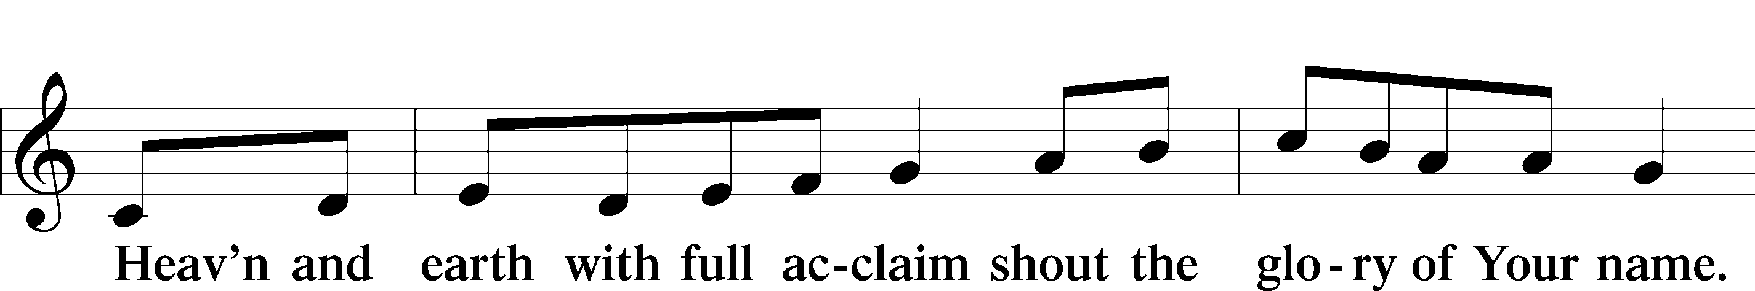
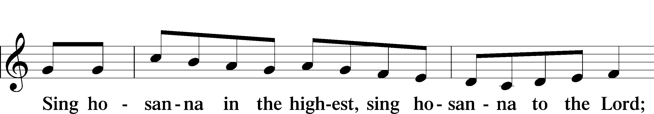
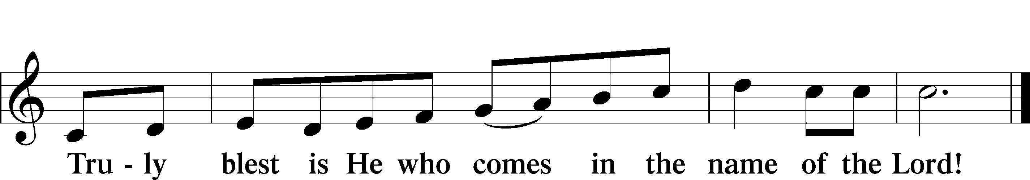
Text: Stephen P. Starke

PRAYER OF THANKSGIVING

Pastor: We give You thanks, almighty God, that You have given us all we need for this body and life. We especially give You thanks for the sacrifice of Your Son, Jesus Christ, that we have been forgiven on the cross. As we come to partake of His true body and blood shed for us, help us to do it not just with sorrow for our sins but also with thanksgiving for salvation received and strength to live a new life filled with thankful hearts every day; through the same Jesus Christ, Your Son, our Lord, who lives and reigns with You and the Holy Spirit, one God, now and forever.
People: Amen.

THE WORDS OF OUR LORD Matthew 26:26–28; Mark 14:22–24; Luke 22:19–20;
1 Corinthians 11:23–25

Pastor: Our Lord Jesus Christ, on the night when He was betrayed, took bread, and when He had given thanks, He broke it and gave it to the disciples and said: “Take, eat; this is My body, which is given for you. This do in remembrance of Me.”
In the same way also He took the cup after supper, and when He had given thanks, He gave it to them, saying: “Drink of it, all of you; this cup is the new testament in My blood, which is shed for you for the forgiveness of sins. This do, as often as you drink it, in remembrance of Me.”

LORD’S PRAYER Matthew 6:9–13

People: Our Father who art in heaven,
hallowed be Thy name,
Thy kingdom come,
Thy will be done on earth
as it is in heaven;
give us this day our daily bread;
and forgive us our trespasses
as we forgive those
who trespass against us;
and lead us not into temptation,
but deliver us from evil.
For Thine is the kingdom
and the power and the glory
forever and ever. Amen.

PAX DOMINI

Pastor: The peace of the Lord be with you always.
People: Amen.

AGNUS DEI (p. 210 in hymnal) (A/89)

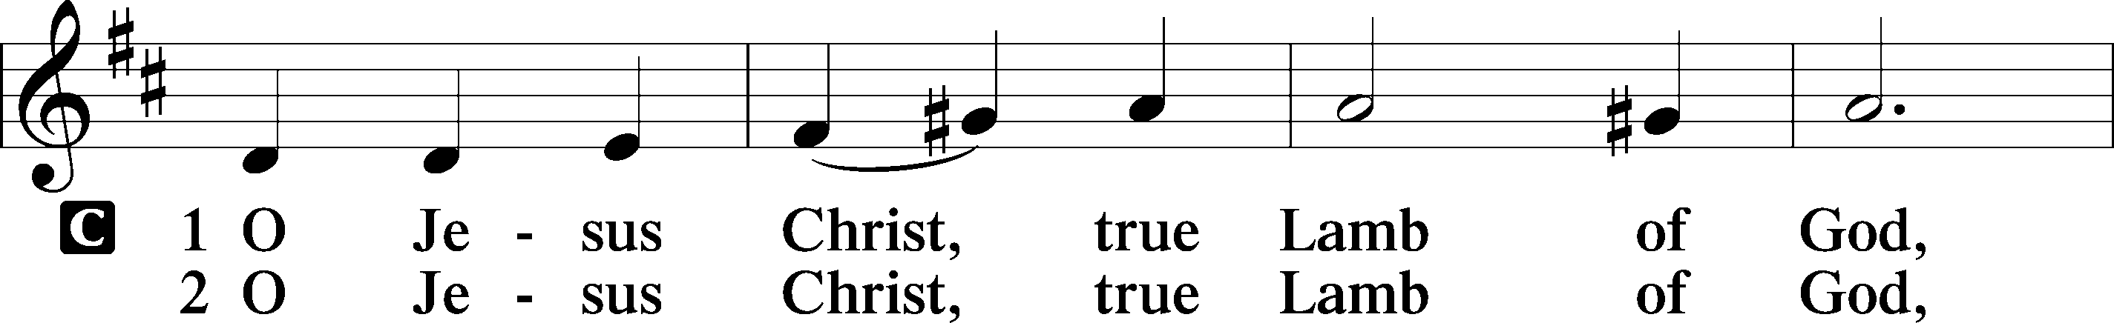
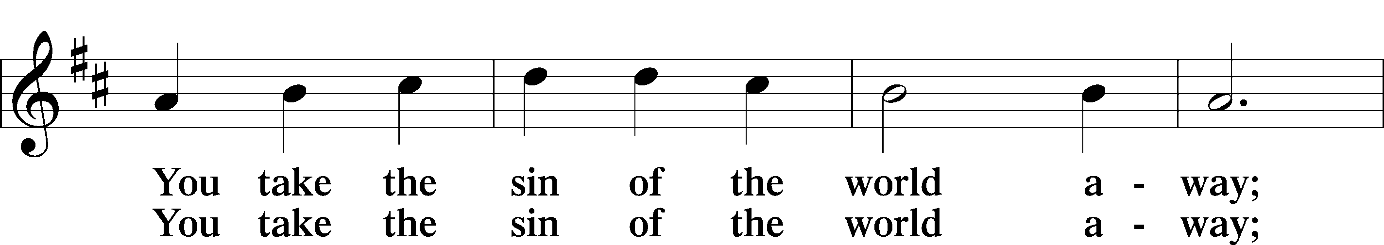
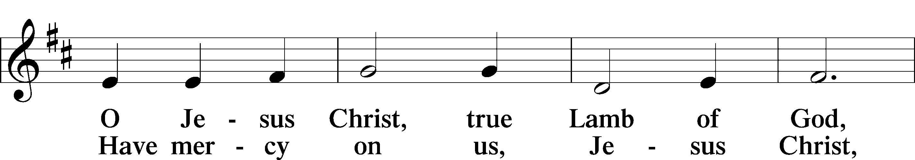
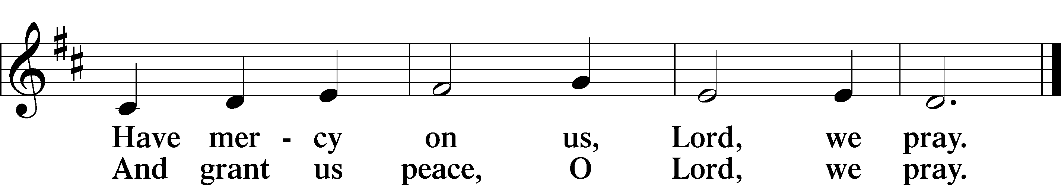
Text: Stephen P. Starke

DISTRIBUTION HYMNS

“O Bless the Lord, My Soul” [LSB 814]

1 O bless the Lord, my soul!
Let all within me join
And aid my tongue to bless His name
Whose favors are divine.

2 O bless the Lord, my soul,
Nor let His mercies lie
Forgotten in unthankfulness
And without praises die!

3 ’Tis He forgives thy sins;
’Tis He relieves thy pain;
’Tis He that heals thy sicknesses
And makes thee young again.

4 He crowns thy life with love
When ransomed from the grave;
He that redeemed my soul from hell
Hath sov’reign pow’r to save.

5 He fills the poor with good;
He gives the suff’rers rest.
The Lord hath judgments for the proud
And justice for th’oppressed.

6 His wondrous works and ways
He made by Moses known,
But sent the world His truth and grace
By His belovèd Son.
Text: Isaac Watts, 1674–1748
Text: Public domain

“For the Fruits of His Creation” [LSB 894]

1 For the fruits of His creation,
Thanks be to God.
For His gifts to ev’ry nation,
Thanks be to God.
For the plowing, sowing, reaping,
Silent growth while we are sleeping,
Future needs in earth’s safekeeping,
Thanks be to God.

2 In the just reward of labor,
God’s will is done.
In the help we give our neighbor,
God’s will is done.
In our worldwide task of caring
For the hungry and despairing,
In the harvests we are sharing,
God’s will is done.

3 For the harvests of the Spirit,
Thanks be to God.
For the good we all inherit,
Thanks be to God.
For the wonders that astound us,
For the truths that still confound us,
Most of all, that love has found us,
Thanks be to God.
Text: Fred Pratt Green, 1903–2000
Text: © 1970 Hope Publishing Co. Used by permission: LSB Hymn License no. 110004005

POST-COMMUNION THANKSGIVING

Pastor: Let us give thanks unto the Lord,
People: for His mercy endures forever.

Pastor: We pray.
We give You thanks, almighty God, that through Your wisdom You sacrificed Your Son, and through His death and resurrection, we now have peace with You. Help us not act as fools, scorning our salvation or considering it a trite thing, but to be wise and receive the great gifts of life and salvation now and for the age to come; through Jesus Christ, Your Son, our Lord, who lives and reigns with You and the Holy Spirit, one God, now and forever.
People: Amen.

BENEDICTION Numbers 6:24–26

Pastor: The Lord bless you and keep you.
The Lord make His face shine on you and be gracious to you.
The Lord look upon you with favor and give you peace.
People: Amen.

HYMN “Now Thank We All Our God” [LSB 895] (26/23)

1 Now thank we all our God
With hearts and hands and voices,
Who wondrous things has done,
In whom His world rejoices;
Who from our mothers’ arms
Has blest us on our way
With countless gifts of love
And still is ours today.

2 Oh, may this bounteous God
Through all our life be near us,
With ever joyful hearts
And blessèd peace to cheer us
And keep us in His grace
And guide us when perplexed
And free us from all ills
In this world and the next!

3 All praise and thanks to God
The Father now be given,
The Son, and Him who reigns
With them in highest heaven,
The one eternal God,
Whom earth and heav’n adore;
For thus it was, is now,
And shall be evermore.
Text: Martin Rinckart, 1586–1649; tr. Catherine Winkworth, 1827–78, alt.
Text: Public domain

Creative Worship for the Lutheran Parish, Series C, Quarter 4.
Copyright © 2025 Concordia Publishing House. All rights reserved. Used by permission.
Acknowledgments
Unless otherwise indicated, Scripture quotations are from the ESV® Bible (The Holy Bible, English Standard Version®), copyright © 2001 by Crossway, a publishing ministry of Good News Publishers. Used by permission. All rights reserved.
Created by Lutheran Service Builder © 2025 Concordia Publishing House

ANNOUNCEMENTS

FIRST SUNDAY IN ADVENT: Next Sunday we begin a New Church Year. After the Divine Service we will clean the church and decorate for Christmas. A meal will be supplied. Ron is bringing pizza, Becky is bringing a salad and Mary, and I will bring Calzones.

MIDWEEK ADVENT SERVICES: They will begin on Wednesday December 3rd. We will have meal at 6:00 p.m. sponsored by the LWML. Our first meal will be baked potatoes. There is a sign-up sheet on the bulletin board going into the kitchen.

VISITORS’ CARDS: In the pew racks we have visitor cards. We would like our visitors to fill out the bottom portion and place it in the offering plate.

UP AND COMING EVENTS:

Sunday, November 23 will be choose your hymn Sunday.
Thanksgiving Eve Service on Wednesday November 26 w/Holy Communion at 7:00 p.m.
First Sunday in Advent, November 30. After the Divine Service we will Decorate and Clean the church. A meal will be provided.
First Midweek Advent Dinner and Devotion: December 3. Dinner at 6:00 p.m. Baked Potato.
Second Midweek Advent Dinner and Devotion: December 10. Dinner at 6:00 p.m. Mexican.
Voter’s Meeting Sunday December 14 after the Divine Service, Meal After the meeting
Third Midweek Advent Dinner and Devotion: December 17, Dinner at 6:00 p.m. Italian.
LWML Sponsored Christmas Meal for the Congregation – All are invited after the Divine Service – Sunday December 21.
Christmas Eve Service with Holy Communion December 24 at 7:00 p.m.
Sunday December 28 will be Choose your Hymn Sunday.

SUNDAY SCHOOL & BIBLE CLASS----------8:45 A.M.
DIVINE SERVICE -------------------------10:00 A.M.
COMMUNION--------1st, 2nd, 3rd and 5th Sundays
VACANCY PASTOR----------------Gary A. Bickner
OFFICE PHONE----------------------------863-3375
HOME PHONE------------------------505-399-8387
E-MAIL…………………………tlcgallup@gmail.com
WEBSITE………..……trinitylutherangallup.com
SUMMER WORSHIP HOURS-------------9:00 a.m.
(Memorial Weekend through and including Labor Day Weekend)
BIBLE STUDIES AS ADVERTISED

