TRINITY LUTHERAN CHURCH (L.C.M.S.)
1100 E. MESA AVE. P.O. BOX 2860
GALLUP, NM 87305-2860
OFFICE: (505) 863-3375
tlcgallup@gmail.com
Web: trinitygallup.org

REFORMATION DAY
True Freedom
October 31, 2025

AS WE GATHER

We are blessed with many freedoms in this country. We have freedom of speech. We have freedom of religion, with the freedom to assemble. We live in the “land of the free and the home of the brave.” It is easy to rely on our citizenship for proof of our freedom. In that way, we are like the Jewish people at the time of Jesus. They relied on their Abrahamic lineage for freedom, recalling the covenant God made with Abraham and his descendants. While these national freedoms are great blessings, in the Holy Gospel, Jesus points out that for true freedom, one must be free from slavery to sin. Only in Christ is anyone truly free.

PRAYER BEFORE WORSHIP: O Lord, my creator, redeemer, and comforter, as I come to worship you in spirit and in truth, I humbly pray that You would open my heart to the preaching of Your word so that I may repent of my sins, believe in Jesus Christ as my only Savior, and grow in grace and holiness. Hear me for the sake of his name. Amen.

HOLY COMMUNION: The Lord’s Supper is celebrated at this congregation in the confession and glad confidence that, as he says, our Lord gives into our mouths not only bread and wine but - his very body and blood to eat and to drink for the forgiveness of sins and to strengthen our union with Him and with one another. Our Lord invites to His table those who trust His words, repent of all sin, and set aside any refusal to forgive and love as he forgives and loves us, that they may show forth His death until He comes.

WELCOME
LIGHTING OF THE CANDLES
PRELUDE “A Mighty Fortress Is Our God” (32/2)

PREPARATION

HYMN

INVOCATION

Pastor: In the name of the Father and of the Son and of the Holy Spirit.
People: Amen.

OPENING SENTENCES Psalm 46:1, 7, 10–11

Pastor: God is our refuge and strength, a very present help in trouble.
People: The Lord of hosts is with us; the God of Jacob is our fortress.
Pastor: “Be still, and know that I am God. I will be exalted among the nations, I will be exalted in the earth!”
People: The Lord of hosts is with us; the God of Jacob is our fortress.

CONFESSION AND ABSOLUTION Isaiah 35:10

Pastor: Let us confess our sins to God, our Father.
People: Almighty God, You are our mighty fortress. We resist this reality when we live according to the so-called wisdom of the world. We resist the reality that, in Christ, we are free indeed when we use our law-keeping as a measure of our standing with You. We resist the reality that You are with us when we celebrate Your works as our own. Still our selfish nature and forgive our sins for Jesus’ sake. Gladden our hearts and set us free.
Pastor: The prophet Isaiah reminds us, “The ransomed of the Lord shall return and come to Zion with singing; everlasting joy shall be upon their heads; they shall obtain gladness and joy, and sorrow and sighing shall flee away.” This is our reality as Jesus forgives us and sets us free. As a called and ordained servant of Christ and by His authority, I forgive You all your sins in the name of the Father and of the Son and of the Holy Spirit.
People: Amen.
(Passing of the peace)
WORD

INTROIT Psalm 34:1–2, 11, 22; antiphon: Psalm 119:46

Leader: I will speak of Your testimonies before kings, O Lord, and shall not be put to shame.
People: I will bless the Lord at all times; His praise shall continually be in my mouth.

Leader: My soul makes its boast in the Lord; let the humble hear and be glad.
People: Come, O children, listen to me; I will teach you the fear of the Lord.

Leader: The Lord redeems the life of His servants; none of those who take refuge in Him will be condemned.
People: Glory be to the Father and to the Son
and to the Holy Spirit;
as it was in the beginning,
is now, and will be forever. Amen.

Leader: I will speak of Your testimonies before kings, O Lord, and shall not be put to shame.

HYMN OF PRAISE
SALUTATION

Leader: The Lord be with you.
People: And also with you.

PRAYER OF THE DAY

Leader: Let us pray.
O God of glory, we worship You who made heaven and earth, the sea and the springs of water. We worship You who freely forgives us through the propitiation of Jesus’ blood, which justifies us freely by Your grace; through Jesus Christ, Your Son, our Lord, who lives and rules with You, in the unity of the Holy Spirit, ever one God, world without end.
People: Amen.

The Son of God Has Set Us Free from Sin and Death by His Grace

“Wisdom is justified by her deeds” (Matt. 11:19), and the true Wisdom of God, Christ Jesus, the incarnate Son, justifies us by His deeds. He prepares His way by the preaching of repentance, but He has suffered the violence of the Law and voluntarily handed Himself over to violent men, that we might eat and drink with Him in His kingdom and “remain in the house forever” (John 8:35). For He is “a friend of tax collectors and sinners” (Matt. 11:19), and He has rescued us by His grace from the slavery of sin and death. By the proclamation of His eternal Gospel “to those who dwell on earth, to every nation and tribe and language and people” (Rev. 14:6), “the righteousness of God has been manifested apart from the law” (Rom. 3:21), “that he might be just and the justifier of the one who has faith in Jesus” (Rom. 3:26). And by hearing the Gospel of Christ Jesus, “whom God put forward as a propitiation by his blood, to be received by faith” (Rom. 3:25), “you will know the truth, and the truth will set you free” (John 8:32).

FIRST READING Revelation 14:6–7 (Fear God and worship Him.)

Lector: Then I saw another angel flying directly overhead, with an eternal gospel to proclaim to those who dwell on earth, to every nation and tribe and language and people. And he said with a loud voice,
People: “Fear God and give Him glory, because the hour of his judgment has come, and worship Him who made heaven and earth, the sea and the springs of water.”

Lector: This is the Word of the Lord.
People: Thanks be to God.

PSALM Psalm 46

Leader: God is our refuge and strength, a very present help in trouble.
People: Therefore we will not fear though the earth gives way, though the mountains be moved into the heart of the sea, though its waters roar and foam, though the mountains tremble at its swelling.

Leader: There is a river whose streams make glad the city of God, the holy habitation of the Most High.
People: God is in the midst of her; she shall not be moved;

Leader: God will help her when morning dawns.
People: The nations rage, the kingdoms totter;

Leader: He utters His voice, the earth melts.
People: The Lord of hosts is with us; the God of Jacob is our fortress.

Leader: Come, behold the works of the Lord, how He has brought desolations on the earth.
People: He makes wars cease to the end of the earth; He breaks the bow and shatters the spear; He burns the chariots with fire.

Leader: “Be still, and know that I am God. I will be exalted among the nations, I will be exalted in the earth!”
People: The Lord of hosts is with us; the God of Jacob is our fortress.

EPISTLE Romans 3:19–28 (All have sinned and are freely justified by God’s grace.)

19Now we know that whatever the law says it speaks to those who are under the law, so that every mouth may be stopped, and the whole world may be held accountable to God. 20For by works of the law no human being will be justified in his sight, since through the law comes knowledge of sin.
21But now the righteousness of God has been manifested apart from the law, although the Law and the Prophets bear witness to it— 22the righteousness of God through faith in Jesus Christ for all who believe. For there is no distinction: 23for all have sinned and fall short of the glory of God, 24and are justified by his grace as a gift, through the redemption that is in Christ Jesus, 25whom God put forward as a propitiation by his blood, to be received by faith. This was to show God’s righteousness, because in his divine forbearance he had passed over former sins. 26It was to show his righteousness at the present time, so that he might be just and the justifier of the one who has faith in Jesus.
27Then what becomes of our boasting? It is excluded. By what kind of law? By a law of works? No, but by the law of faith. 28For we hold that one is justified by faith apart from works of the law.

Lector: This is the Word of the Lord.
People: Thanks be to God.

VERSE Luke 12:32

Pastor: Alleluia.
People: Fear not, little flock, for it is your Father’s good pleasure to give you the kngdom.
Pastor: Alleluia.

HOLY GOSPEL John 8:31–36 (It is only through Jesus that we become free.)

Pastor: The Holy Gospel according to St. John, the eighth chapter.
People: Glory to You, O Lord.

Pastor: So Jesus said to the Jews who had believed in Him, “If you abide in My word, you are truly My disciples, and you will know the truth, and the truth will set you free.”
People: They answered Him, “We are offspring of Abraham and have never been enslaved to anyone. How is it that you say, ‘You will become free’?”
Pastor: Jesus answered them, “Truly, truly, I say to you, everyone who commits sin is a slave to sin. The slave does not remain in the house forever; the son remains forever. So if the Son sets you free, you will be free indeed.”

Pastor: This is the Gospel of the Lord.
People: Praise to You, O Christ.

CHILDREN’S MESSAGE

HYMN OF THE DAY

SERMON
Text: Romans 3:19-28
Theme: “To Be Held Accountable to God”

The First Article
Creation
I believe in God, the Father Almighty, maker of heaven and earth.

What does this mean?
I believe that God has made me and all creatures; that He has given me my body and soul, eyes, ears, and all my members, my reason and all my senses, and still takes care of them.

He also gives me clothing and shoes, food and drink, house and home, wife and children, land, animals, and all I have. He richly and daily provides me with all that I need to support this body and life.

He defends me against all danger and guards and protects me from all evil. All this He does only out of fatherly, divine goodness and mercy, without any merit or worthiness in me. For all this it is my duty to thank and praise, serve and obey Him.
This is most certainly true.

OFFERING

PRAYER OF THE CHURCH

Leader: Let us pray for the whole people of God in Christ Jesus and for all people according to their needs.

People: O Lord of hosts, we give You glory and thanks for being our refuge and strength, a very present help in trouble, especially on this Reformation festival.

Leader: Thank You for the gift of Your grace that alone sets us free through the blood of Your Son, Jesus.

People: Faithful and forgiving God, thank You for bringing us to faith in You. It is through this faith alone that we are saved. Grow us in Your grace and guide us by Your Spirit in living our faith daily.

Leader: O Word who became flesh and dwelt among us, You have given us the Word of Life. Strengthen us by Your Word. Lead and guide us by Your truth. Give Your church on earth faithful pastors who preach and teach the Gospel in all its purity.

Special Intercessions
(Lord, in Your mercy, hear our prayer.)

Leader: Preserve Your church, O Lord, and each of us as members of Christ’s Body, that we may not surrender the t rue Gospel for any reason but be kept in this faith and fear throughout the days of our earthly pilgrimage, until that day when we and all Your people shall stand before the judgment seat of Christ to receive the reward You have prepared for us and all who have loved His appearing. To You alone be all glory, now and forever, for You rule and reign as one God: Father, Son, and Holy Spirit.
People: Amen.

The Second Article
Redemption
And in Jesus Christ, His only Son, our Lord, who was conceived by the Holy Spirit, born of the virgin Mary, suffered under Pontius Pilate, was crucified, died and was buried. He descended into hell. The third day He rose again from the dead. He ascended into heaven and sits at the right hand of God the Father Almighty. From thence He will come to judge the living and the dead.

What does this mean?
I believe that Jesus Christ, true God, begotten of the Father from eternity, and also true man, born of the virgin Mary, is my Lord,

who has redeemed me, a lost and condemned person, purchased and won me from all sins, from death, and from the power of the devil; not with gold or silver, but with His holy, precious blood and with His innocent suffering and death,

that I may be His own and live under Him in His kingdom and serve Him in everlasting righteousness, innocence, and blessedness,

just as He is risen from the dead, lives and reigns to all eternity.

This is most certainly true.

SACRAMENT

PREFACE 2 Timothy 4:22

Pastor: The Lord be with you.
People: And also with you.

Pastor: Lift up your hearts.
People: We lift them to the Lord.

Pastor: Let us give thanks to the Lord our God.
People: It is right to give Him thanks and praise.

PROPER PREFACE

Pastor: It is good, right, and salutary that we should at all times and in all places give thanks to You, O Lord, our God, for You have set us free and justified us by Your grace, as a gift through the redemption that is in Christ Jesus, whom You put forward as a propitiation by His blood. Because He is now risen from the dead and lives and reigns to all eternity, all who believe in Him are set free from the power of sin and death and will rise again to new life in the city of God, the place of Your holy habitation. Therefore with angels and archangels and all the company of heaven we laud and magnify Your glorious name, evermore praising You and saying:

SANCTUS (p. 208 in hymnal) (A/88)

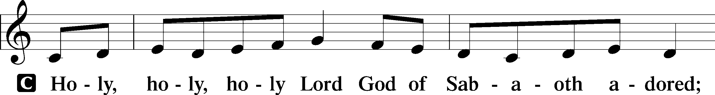
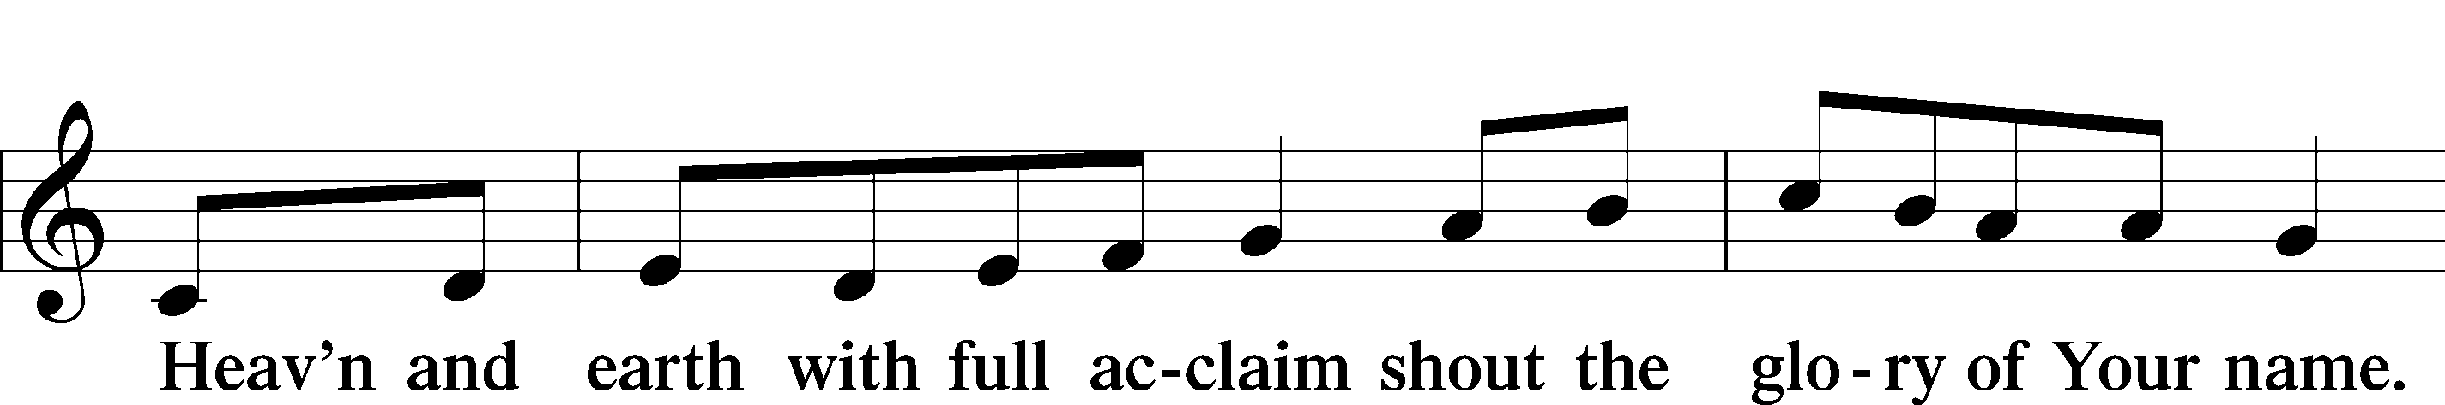
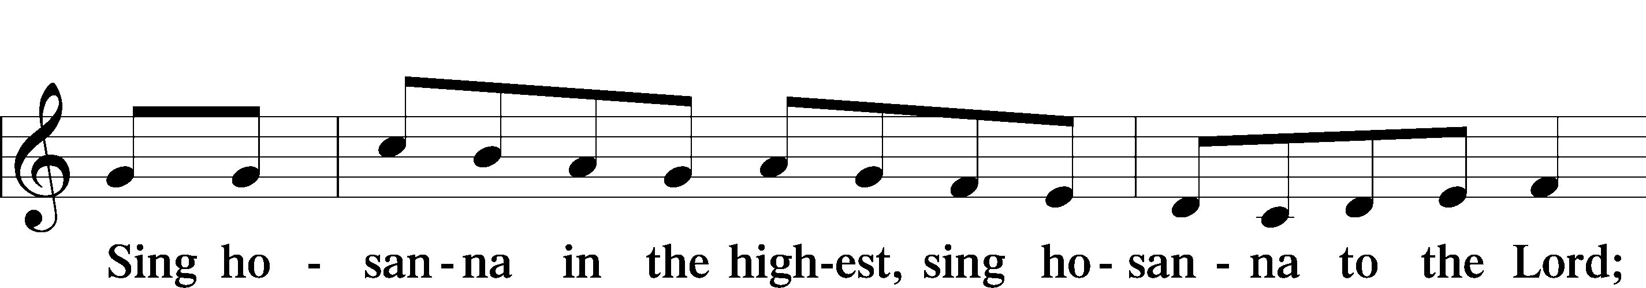
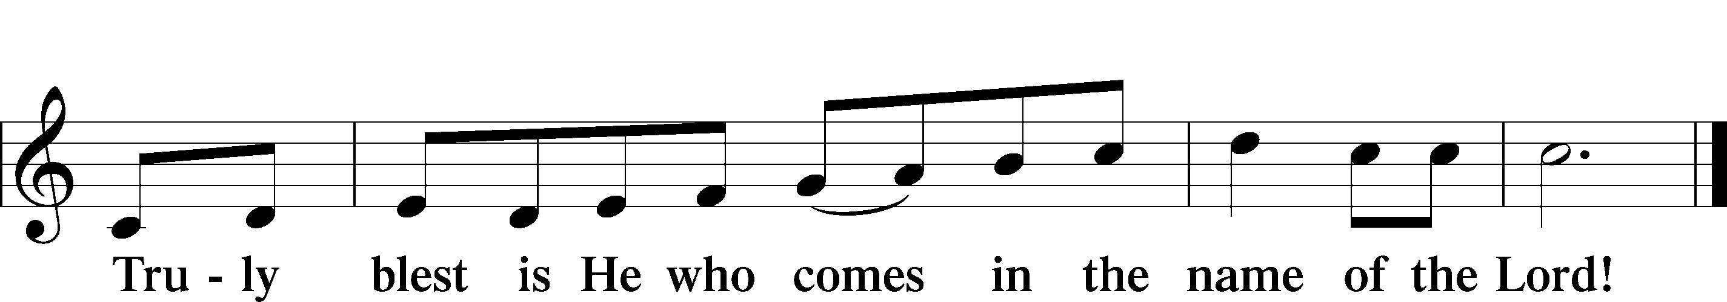
Text: Stephen P. Starke

PRAYER OF THANKSGIVING

Pastor: Blessed are You, O Lord of hosts, the God of Jacob, our fortress, for You have had mercy on all whom You have created by sending Your Son, Jesus, whom God put forward as a propitiation by His blood, to be received by faith.
As we gather in Your name and the memory of Jesus, we beg You, O Lord, to forgive, renew, and strengthen us with Your Word and Spirit. Lead us to faithfully eat and drink His body and blood. Gather us together as we celebrate the freedom we have in Christ. Graciously receive our prayers; deliver and preserve us. To You alone, O Father, be all glory, honor, and worship, with the Son and the Holy Spirit, one God, now and forever.
People: Amen.

THE WORDS OF OUR LORD Matthew 26:26–28; Mark 14:22–24; Luke 22:19–20;1 Corinthians 11:23–25

Pastor: Our Lord Jesus Christ, on the night when He was betrayed, took bread, and when He had given thanks, He broke it and gave it to the disciples and said: “Take, eat; this is My body, which is given for you. This do in remembrance of Me.”
In the same way also He took the cup after supper, and when He had given thanks, He gave it to them, saying: “Drink of it, all of you; this cup is the new testament in My blood, which is shed for you for the forgiveness of sins. This do, as often as you drink it, in remembrance of Me.”

PROCLAMATION OF CHRIST 1 Corinthians 11:26; Revelation 22:20

Pastor: As often as we eat this bread and drink this cup, we proclaim the Lord’s death until He comes.
People: Amen. Come, Lord Jesus.

Pastor: O Lord Jesus Christ, only Son of the Father, in giving us Your body and blood to eat and to drink, You lead us to remember and confess Your holy cross and passion, Your blessed death, Your rest in the tomb, Your resurrection from the dead, Your ascension into heaven, and Your coming for the final judgment. So remember us in Your kingdom and teach us to pray:

LORD’S PRAYER Matthew 6:9–13

People: Our Father who art in heaven,
hallowed be Thy name,
Thy kingdom come,
Thy will be done on earth
as it is in heaven;
give us this day our daily bread;
and forgive us our trespasses
as we forgive those
who trespass against us;
and lead us not into temptation,
but deliver us from evil.
For Thine is the kingdom
and the power and the glory
forever and ever. Amen.

PAX DOMINI

Pastor: The peace of the Lord be with you always.
People: Amen.

AGNUS DEI (p. 210 in hymnal) (A/89)

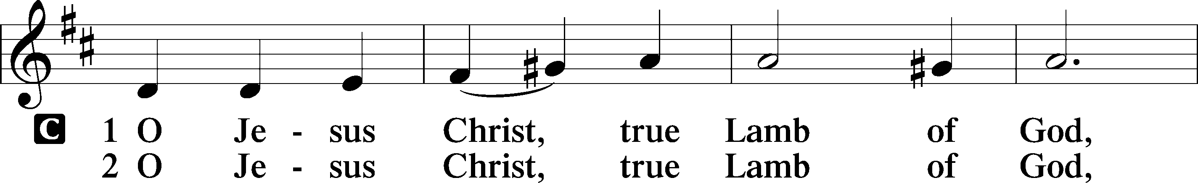
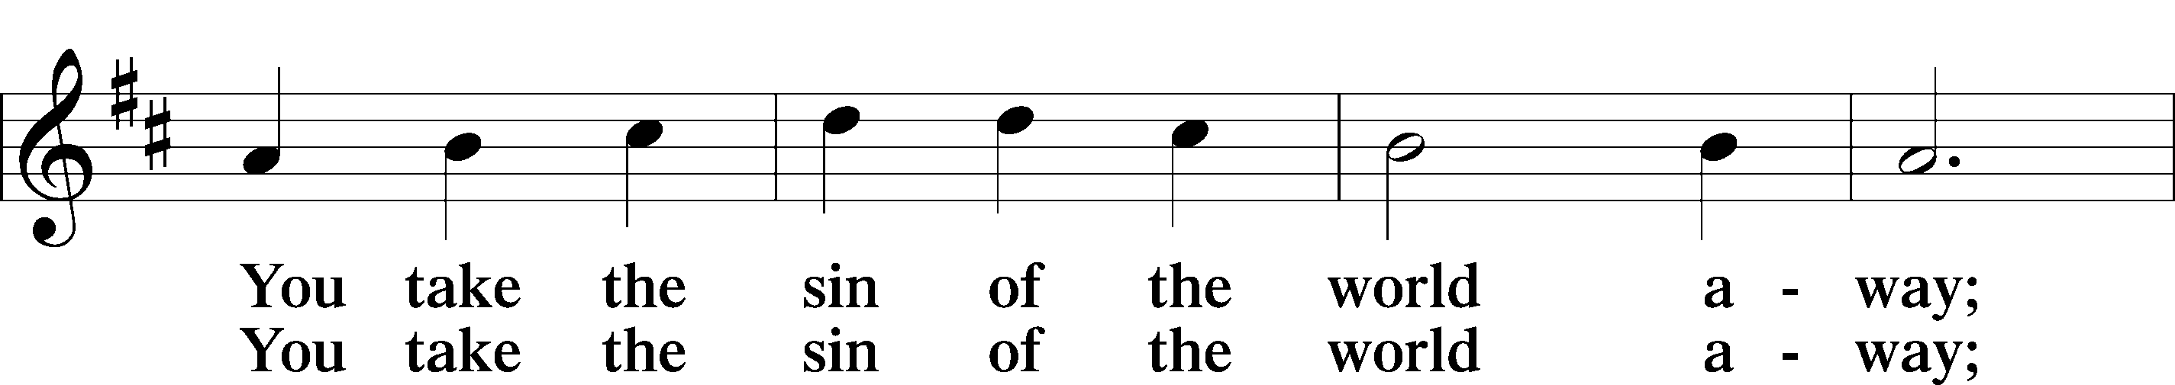
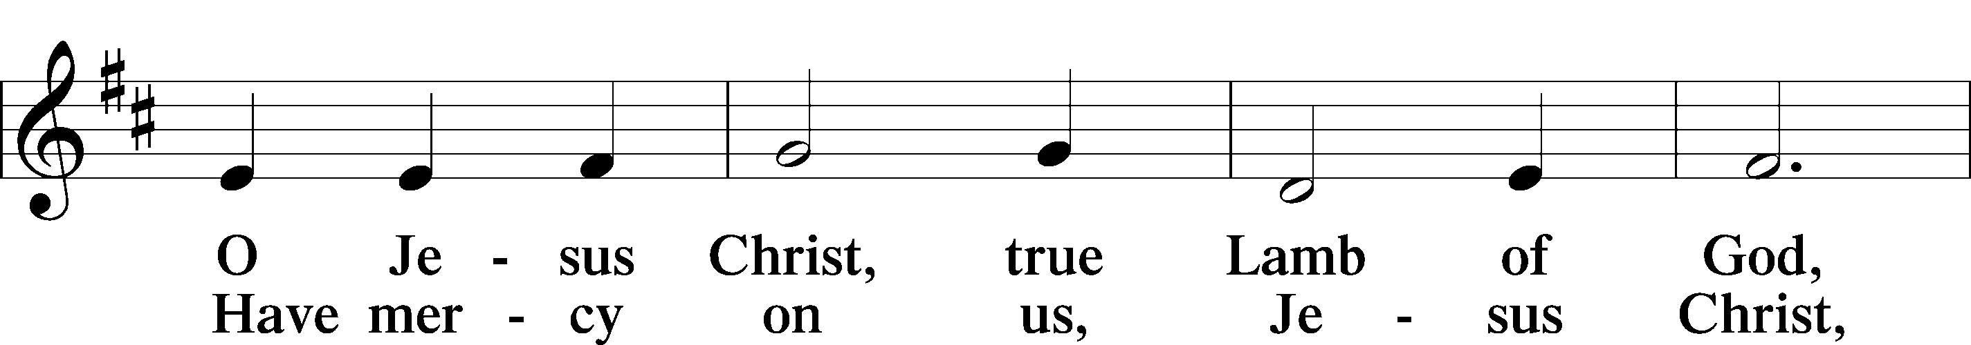
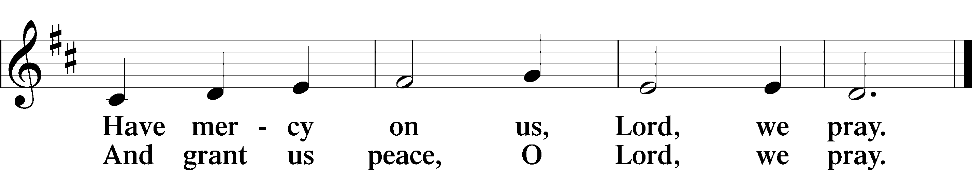
Text: Stephen P. Starke

DISTRIBUTION HYMNS

The Third Article
Sanctification
I believe in the Holy Spirit, the holy Christian Church, the communion of saints, the forgiveness of sins, the resurrection of the body, and the life everlasting. Amen.

What does this mean?
I believe that I cannot by my own reason or strength believe in Jesus Christ, my Lord, or come to Him; but the Holy Spirit has called me by the Gospel, enlightened me with His gifts, sanctified and kept me in the true faith.

In the same way He calls, gathers, enlightens, and sanctifies the whole Christian Church on earth, and keeps it with Jesus Christ in the one true faith.

In this Christian Church He daily and richly forgives all my sins and the sins of all believers.

On the Last Day He will raise me and all the dead, and give eternal life to me and all believers in Christ.

This is most certainly true.

POST-COMMUNION THANKSGIVING

Pastor: Let us pray.
O God of Jacob, we give You glory for sending Your Son to set us free. We thank You for setting this feast of forgiveness before us. Empower us to proclaim Your eternal Gospel to all who dwell on earth, to every nation and tribe and language and people; through Jesus Christ, Your Son, our Lord, who lives and reigns with You and the Holy Spirit, one God, now and forever.
People: Amen.

BENEDICTION Psalm 46:1, 7, 10–11; Numbers 6:24–26

Pastor: God is our refuge and strength, a very present help in trouble.
People: The Lord of hosts is with us; the God of Jacob is our fortress.
Pastor: “Be still, and know that I am God. I will be exalted among the nations, I will be exalted in the earth!”
People: The Lord of hosts is with us; the God of Jacob is our fortress.

Pastor: The Lord bless you and keep you.
The Lord make His face shine on you and be gracious to you.
The Lord look upon you with favor and give you peace.
People: Amen.

HYMN

Creative Worship for the Lutheran Parish, Series C, Quarter 4.
Copyright © 2025 Concordia Publishing House. All rights reserved. Used by permission.
Unless otherwise indicated, Scripture quotations are from the ESV® Bible (The Holy Bible, English Standard Version®), copyright © 2001 by Crossway, a publishing ministry of Good News Publishers. Used by permission. All rights reserved.
Created by Lutheran Service Builder © 2025 Concordia Publishing House.

ANNOUNCEMENTS

BIRTHDAYS THIS WEEK: John Matajcich 10/27; Cheyenne Gavaldon 10/28; Lynn Isaacson 10/28,

WOMEN’S BIBLE STUDY: They will continue to meet on Mondays at 6:30 p.m. here at the church. The study will be “Great Women of the Bible II.”

WEDNESDAY BIBLE STUDY: We will continue our study this Wednesday here at church at 7:00 p.m.

THANKS: Go to all who came out yesterday to clean the church. Your help is greatly appreciated. It is always nice to have the church looking good as we join together in praising and glorifying our Lord.

TIME CHANGE: Next Sunday we will go from Daylight Savings Time back to Mountain standard time. Remember to turn your clocks back one hour.

ALL SAINT’S SUNDAY OBSERVATION: This will take place on next Sunday, November 2.

LWML: They will have their regular monthly meeting on Sunday, November 2 after the Divine Service.

VISITORS’ CARDS: In the pew racks we have visitor cards. We would like our visitors to fill out the bottom portion and place it in the offering plate.

PRAYER REQUEST CARDS: In the pew racks are request cards for prayers. If you have a special request please fill out this card and see that the Pastor gets it before worship or give to the ushers during the offering.

FLOWERS ON THE ALTAR: If you would like to place flowers on the altar. There is a form on the back pew. Flowers help add to the beauty of the Service.

SUNDAY SCHOOL & BIBLE CLASS----------8:45 A.M.
DIVINE SERVICE -------------------------10:00 A.M.
COMMUNION--------1st, 2nd, 3rd and 5th Sundays
VACANCY PASTOR----------------Gary A. Bickner
OFFICE PHONE----------------------------863-3375
HOME PHONE------------------------505-399-8387
E-MAIL…………………………tlcgallup@gmail.com
WEBSITE………..……trinitylutherangallup.com
SUMMER WORSHIP HOURS-------------9:00 a.m.
(Memorial Weekend through and including Labor Day Weekend)
BIBLE STUDIES AS ADVERTISED

