TRINITY LUTHERAN CHURCH (L.C.M.S.)
1100 E. MESA AVE. P.O. BOX 2860
GALLUP, NM 87305-2860
OFFICE: (505) 863-3375
tlcgallup@gmail.com
Web: trinitygallup.org

FIRST SUNDAY IN ADVENT
Prepare the Way of the Lord
November 30, 2025

AS WE GATHER: Today is not only the First Sunday in Advent but also the commemoration of St. Andrew, whose day governs the start of Advent. In this way, Andrew continues to point to Christ as we begin a new Church Year. How odd it is, then, that the Gospel for the First Sunday in Advent is the same as the Gospel for Palm Sunday! This reminds us that Jesus came for the cross and empty tomb, and this is the only Gospel that can save us from sin and death. The cry of Advent is “prepare the way of the Lord.” We will echo the words of John the Baptist, heralding Christ’s coming. We will join in the chant of the crowd: “Hosanna to the Son of David!” (Matthew 21:9). We will hear Him speak to us through the voice of His Word. We will feast upon His flesh for the life of the world and His blood that cleanses us from all sin. In all our preparations, we acclaim Him as Lord and receive Him and all His benefits.

PRAYER BEFORE WORSHIP: O Lord, my creator, redeemer, and comforter, as I come to worship you in spirit and in truth, I humbly pray that You would open my heart to the preaching of Your word so that I may repent of my sins, believe in Jesus Christ as my only Savior, and grow in grace and holiness. Hear me for the sake of his name. Amen.

HOLY COMMUNION: The Lord’s Supper is celebrated at this congregation in the confession and glad confidence that, as he says, our Lord gives into our mouths not only bread and wine but - his very body and blood to eat and to drink for the forgiveness of sins and to strengthen our union with Him and with one another. Our Lord invites to His table those who trust His words, repent of all sin, and set aside any refusal to forgive and love as he forgives and loves us, that they may show forth His death until He comes.

PRAYER REQUEST CARDS: In the pew racks are request cards for prayers. If you have a special request please fill out this card and see that the Pastor gets it before worship or give to the ushers during the offering.

WELCOME
LIGHTING OF THE CANDLES
PRELUDE “New Testament Canticle” (31/75)
(From A Service of Prayer and Preaching, Page 266 in hymnal)

PREPARATION

INVOCATION

Pastor: In the name of the Father and of the Son and of the Holy Spirit.
People: Amen.

CONFESSION AND ABSOLUTION Romans 13:12; Philippians 1:6

Pastor: The night is far gone; the day is at hand.
People: So then let us cast off the works of darkness and put on the armor of light.

Silence for self-examination.

Pastor: Holy and gracious God,
People: I confess that I have sinned against You this day. Some of my sin I know—the thoughts and words and deeds of which I am ashamed—but some is known only to You. In the name of Jesus Christ I ask forgiveness. Deliver and restore me that I may rest in peace.
Pastor: Almighty God in His mercy has given His Son to die for you and for His sake forgives you all your sins. As a called and ordained servant of Christ, and by His authority, I therefore forgive you all your sins in the name of the Father and of the Son and of the Holy Spirit.
People: Amen.

Pastor: He who began a good work in you will bring it to completion at the day of Jesus Christ.
People: Amen.
(Passing of the Peace)
WORD

The Advent wreath is lit with the other candles as the hymn is sung.

HYMN “Lift Up Your Heads, Ye Mighty Gates” [LSB 341] (1/11)

1 Lift up your heads, ye mighty gates!
Behold, the King of glory waits.
The King of kings is drawing near;
The Savior of the world is here.
Life and salvation He doth bring;
Therefore rejoice and gladly sing.
To God the Father raise
Your joyful songs of praise.

2 A righteous Helper comes to thee;
His chariot is humility,
His kingly crown is holiness,
His scepter, pity in distress.
The end of all our woe He brings;
Therefore the earth is glad and sings.
To Christ the Savior raise
Your grateful hymns of praise.

3 How blest the land, the city blest,
Where Christ the ruler is confessed!
O peaceful hearts and happy homes
To whom this King in triumph comes!
The cloudless sun of joy is He
Who comes to set His people free.
To God the Spirit raise
Your happy shouts of praise.

4 Fling wide the portals of your heart;
Make it a temple set apart
From earthly use for heav’n’s employ,
Adorned with prayer and love and joy.
So shall your Sov’reign enter in
And new and nobler life begin.
To God alone be praise
For word and deed and grace!

5 Redeemer, come and open wide
My heart to Thee; here, Lord, abide!
O enter with Thy grace divine;
Thy face of mercy on me shine.
Thy Holy Spirit guide us on
Until our glorious goal is won.
Eternal praise and fame
We offer to Thy name.
Text: Georg Weissel, 1590–1635; tr. Catherine Winkworth, 1827–78, alt.
Text: Public domain

SALUTATION

Leader: The Lord be with you.
People: And also with you.

PRAYER OF THE DAY

Leader: Let us pray.
Stir up Your power, O Lord, and come, that by Your protection we may be rescued from the threatening perils of our sins and saved by Your mighty deliverance; for You live and reign with the Father and the Holy Spirit, one God, now and forever.
People: Amen.

The Lord Comes in Meekness and Humility to Save Us Now

The Lord Jesus enters Jerusalem “humble, and mounted on a donkey,” riding on “a beast of burden” (Matt. 21:5), as He Himself bears the sins of the world in His body. Now He comes by the ministry of the Gospel to save us from sin, death, the devil and hell. Therefore, we sing, “Blessed is he who comes in the name of the Lord!” (Matt. 21:9). For we are called “to the mountain of the Lord, to the house of the God of Jacob,” His Holy Church, “that he may teach us his ways and that we may walk in his paths” (Is. 2:3). By His Word, we “walk in the light of the Lord” (Is. 2:5). That is to live in love, which “does no wrong to a neighbor” (Rom. 13:10). We “cast off the works of darkness and put on the armor of light,” for “salvation is nearer to us now than when we first believed” (Rom. 13:11, 12). Hence, the entire Christian life is a time to wake and watch, “for you do not know on what day your Lord is coming” (Matt. 24:42).

OLD TESTAMENT READING Isaiah 2:1–5 (“Come, let us walk in the light of the Lord.”)

1The word that Isaiah the son of Amoz saw concerning Judah and Jerusalem.
2It shall come to pass in the latter days
that the mountain of the house of the Lord
shall be established as the highest of the mountains,
and shall be lifted up above the hills;
and all the nations shall flow to it,
3and many peoples shall come, and say:
“Come, let us go up to the mountain of the Lord,
to the house of the God of Jacob,
that he may teach us his ways
and that we may walk in his paths.”
For out of Zion shall go the law,
and the word of the Lord from Jerusalem.
4He shall judge between the nations,
and shall decide disputes for many peoples;
and they shall beat their swords into plowshares,
and their spears into pruning hooks;
nation shall not lift up sword against nation,
neither shall they learn war anymore.
5O house of Jacob,
come, let us walk
in the light of the Lord.

Lector: This is the Word of the Lord.
People: Thanks be to God.

GRADUAL

Rejoice greatly, O daughter of | Zion.*
Shout aloud, O daughter of Je- | rusalem.
Behold, your king is com- | ing to you;*
righteous and having sal- | vation.
Blessèd is he who comes in the name | of the Lord.*
From the house of the Lord we | bless you.

EPISTLE Romans 13:(8–10) 11–14 (“Put on the armor of light.”)

8Owe no one anything, except to love each other, for the one who loves another has fulfilled the law. 9The commandments, “You shall not commit adultery, You shall not murder, You shall not steal, You shall not covet,” and any other commandment, are summed up in this word: “You shall love your neighbor as yourself.” 10Love does no wrong to a neighbor; therefore love is the fulfilling of the law.
11Besides this you know the time, that the hour has come for you to wake from sleep. For salvation is nearer to us now than when we first believed. 12The night is far gone; the day is at hand. So then let us cast off the works of darkness and put on the armor of light. 13Let us walk properly as in the daytime, not in orgies and drunkenness, not in sexual immorality and sensuality, not in quarreling and jealousy. 14But put on the Lord Jesus Christ, and make no provision for the flesh, to gratify its desires.

Lector: This is the Word of the Lord.
People: Thanks be to God.

VERSE Psalm 24:7

Pastor: Alleluia.
People: Lift up your heads, O gates! And be lifted up, O ancient doors, that the King of glory may come in.
Pastor: Alleluia.

HOLY GOSPEL Matthew 21:1–11 (Rejoice, Jerusalem, for Your Lord comes to You.)

Pastor: The Holy Gospel according to St. Matthew, the twenty-first chapter.
People: Glory to You, O Lord.

(The Gospel is read.)

1Now when they drew near to Jerusalem and came to Bethphage, to the Mount of Olives, then Jesus sent two disciples, 2saying to them, “Go into the village in front of you, and immediately you will find a donkey tied, and a colt with her. Untie them and bring them to me. 3If anyone says anything to you, you shall say, ‘The Lord needs them,’ and he will send them at once.” 4This took place to fulfill what was spoken by the prophet, saying,
5“Say to the daughter of Zion,
‘Behold, your king is coming to you,
humble, and mounted on a donkey,
and on a colt, the foal of a beast of burden.’”
6The disciples went and did as Jesus had directed them. 7They brought the donkey and the colt and put on them their cloaks, and he sat on them. 8Most of the crowd spread their cloaks on the road, and others cut branches from the trees and spread them on the road. 9And the crowds that went before him and that followed him were shouting, “Hosanna to the Son of David! Blessed is he who comes in the name of the Lord! Hosanna in the highest!” 10And when he entered Jerusalem, the whole city was stirred up, saying, “Who is this?” 11And the crowds said, “This is the prophet Jesus, from Nazareth of Galilee.”

Pastor: This is the Gospel of the Lord.
People: Praise to You, O Christ.

CHILDREN’S MESSAGE

HYMN OF THE DAY “Savior of the Nations, Come” [LSB 332] (1/2)

1 Savior of the nations, come,
Virgin’s Son, make here Your home!
Marvel now, O heav’n and earth,
That the Lord chose such a birth.

2 Not by human flesh and blood,
By the Spirit of our God,
Was the Word of God made flesh—
Woman’s offspring, pure and fresh.

3 Here a maid was found with child,
Yet remained a virgin mild.
In her womb this truth was shown:
God was there upon His throne.

4 Then stepped forth the Lord of all
From His pure and kingly hall;
God of God, yet fully man,
His heroic course began.

5 God the Father was His source,
Back to God He ran His course.
Into hell His road went down,
Back then to His throne and crown.

6 For You are the Father’s Son
Who in flesh the vict’ry won.
By Your mighty pow’r make whole
All our ills of flesh and soul.

7 From the manger newborn light
Shines in glory through the night.
Darkness there no more resides;
In this light faith now abides.

8 Glory to the Father sing,
Glory to the Son, our king,
Glory to the Spirit be
Now and through eternity.
Text: attr. Ambrose of Milan, 340–397; German version, Martin Luther, 1483–1546; (sts. 1–2): tr. William M. Reynolds, 1812–76; (sts. 3, 6): tr. Lutheran Service Book, 2006; (sts. 4–5, 8): tr. F. Samuel Janzow, 1913–2001; (st. 7): tr. Gifford A. Grobien, 1973
Text (sts. 1–2): Public domain
Text (sts. 3, 6–7): © 2006 Concordia Publishing House; (sts. 4–5, 8): © 1978 Concordia Publishing House. Used by permission: LSB Hymn License no. 110004005

SERMON
Text: Isaiah 2:1-5
Theme: “We Walk With God”

CREED Nicene Creed

People: I believe in one God,
the Father Almighty,
maker of heaven and earth
and of all things visible and invisible.
And in one Lord Jesus Christ,
the only-begotten Son of God,
begotten of His Father before all worlds,
God of God, Light of Light,
very God of very God,
begotten, not made,
being of one substance with the Father,
by whom all things were made;
who for us men and for our salvation came down from heaven
and was incarnate by the Holy Spirit of the virgin Mary
and was made man;
and was crucified also for us under Pontius Pilate.
He suffered and was buried.
And the third day He rose again according to the Scriptures
and ascended into heaven
and sits at the right hand of the Father.
And He will come again with glory to judge both the living and the dead,
whose kingdom will have no end.
And I believe in the Holy Spirit,
the Lord and giver of life,
who proceeds from the Father and the Son,
who with the Father and the Son together is worshiped and glorified,
who spoke by the prophets.
And I believe in one holy Christian and apostolic Church,
I acknowledge one Baptism for the remission of sins,
and I look for the resurrection of the dead
and the life of the world to come. Amen.

OFFERING

PRAYER OF THE CHURCH

Leader: Stir up Your power, O Lord, to rescue us from the dangers of this dark world by the advent of Your Son, that we may ever walk in His light and learn the way of peace.

People: O God, You have made us glad to enter into Your presence to hear the Good News of our Savior and to receive Your gifts. Preserve Your Church against all her enemies. Lead us to walk in Your ways and to follow Your path, that when Jesus returns in His glory we may welcome Him with glad hosannas.

Leader: O Lord of love, visit our homes and defend us from the temptation to walk in the works of darkness. Clothe us with the armor of light. Preserve the single in holiness, and lead husbands and wives to love one another and raise their children in the faith.

People: Almighty Father, You are the authority to whom all temporal authorities must bow. Give wisdom and godly insight to our president; our governor; and all who make, administer or judge our laws. Grant peace among the nations, that swords may be beaten to plowshares and spears to pruning hooks.

Special Intercessions
(Lord, in Your mercy, hear our prayer.)

Leader: Everlasting God, Your Son has given us a place at His table where we receive the food of His own flesh and blood given for the life of the world. Grant us faith to recognize His body in this bread and His blood in this cup and to receive this blessed communion with joy and thanksgiving. Unite Your people, that we may confess with one voice the truth of Your Word and live together in love and anticipation for that day when Christ shall return in triumph. Bring us with all the saints into Your eternal presence and to the marriage feast of the Lamb without end.

People: Lord God, heavenly Father, we thank, bless and praise You forever that You have sent Your Son to reign over us poor sinners, who for our trespasses deserve rightly to remain in bondage to sin and Satan. You have given us a righteous and humble King who, through His death, has saved us from sin and eternal death. We implore You, enlighten, govern and direct us by Your Holy Spirit, that we may remain faithful to this righteous King and Savior and not be offended by His humble appearance or despised Word, but believe in Him and obtain eternal salvation; through the same Jesus Christ, Your Son, our Lord, who lives and reigns with You and the Holy Spirit, one God, now and forever. Amen.

SACRAMENT

PREFACE 2 Timothy 4:22

Pastor: The Lord be with you.
People: And also with you.

Pastor: Lift up your hearts.
People: We lift them to the Lord.

Pastor: Let us give thanks to the Lord our God.
People: It is right to give Him thanks and praise.

PROPER PREFACE

Pastor: It is truly good, right, and salutary that we should at all times and in all places give thanks to You, holy Lord, almighty Father, everlasting God, through Jesus Christ, our Lord, whose way John the Baptist prepared, proclaiming Him the promised Messiah, the very Lamb of God who takes away the sin of the world, and calling sinners to repentance that they might escape from the wrath to be revealed when He comes again in glory. Therefore with angels and archangels and with all the company of heaven we laud and magnify Your glorious name, evermore praising You and saying:

SANCTUS (p. 161 in hymnal) (A/20)

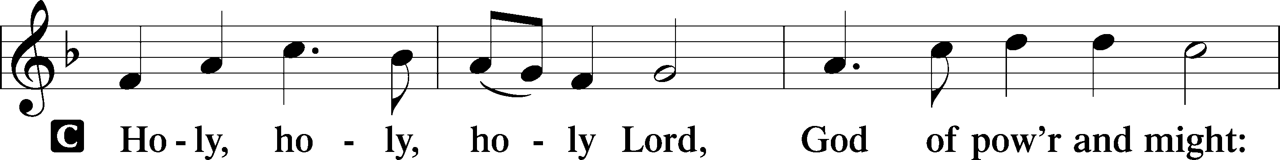
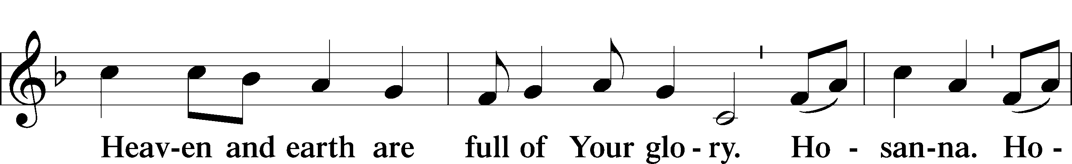
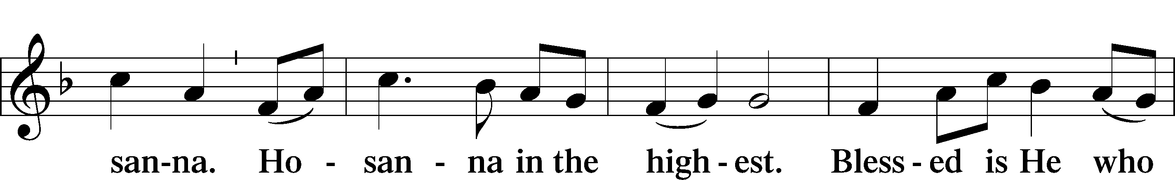
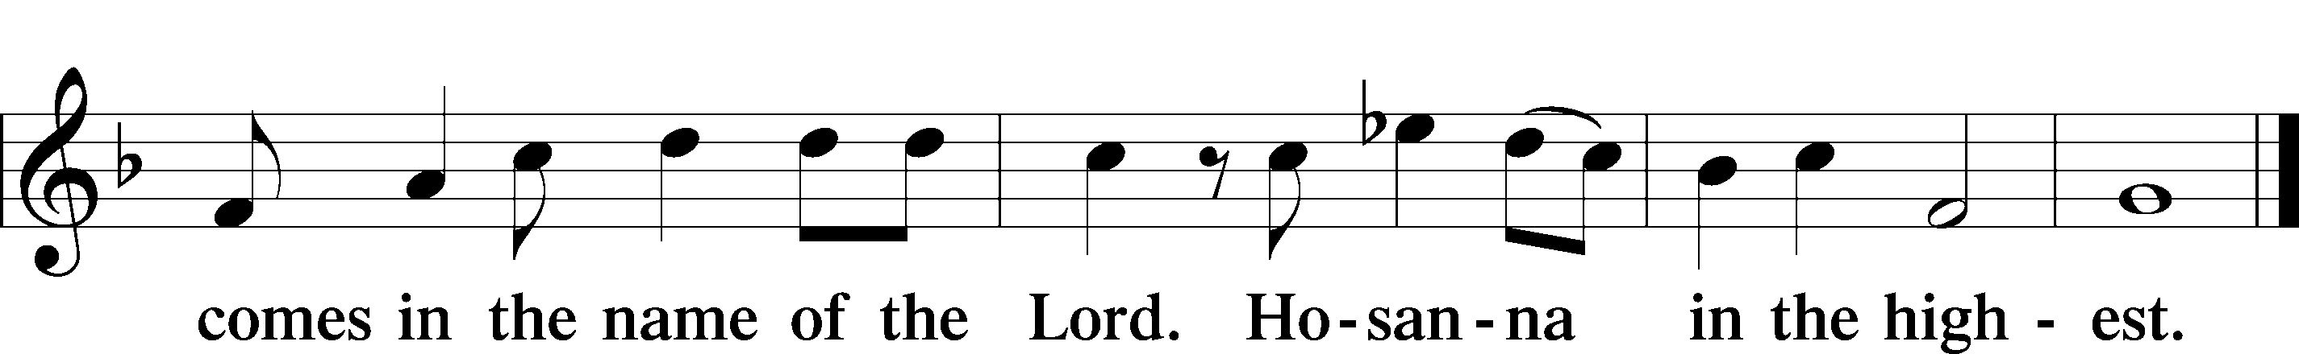

PRAYER OF THANKSGIVING

Pastor: In the dawn of time, You spoke creation and all things into being and proclaimed them good. In many and various ways, O Lord, You spoke through the prophets the promise of a Savior to restore Your people from the exile of sin and death. In the fullness of time, You sent forth Your Son, born of a virgin by the Holy Spirit. Now, You continue to send forth to us the fruits of His redeeming work in this Holy Communion of His body and blood, according to His own promise and testament:

THE WORDS OF OUR LORD Matthew 26:26–28; Mark 14:22–24; Luke 22:19–20;
1 Corinthians 11:23–25

Pastor: Our Lord Jesus Christ, on the night when He was betrayed, took bread, and when He had given thanks, He broke it and gave it to the disciples and said: “Take, eat; this is My body, which is given for you. This do in remembrance of Me.”
In the same way also He took the cup after supper, and when He had given thanks, He gave it to them, saying: “Drink of it, all of you; this cup is the new testament in My blood, which is shed for you for the forgiveness of sins. This do, as often as you drink it, in remembrance of Me.”

Pastor: Lord remember us in your Kingdom and teach us to pray.

LORD’S PRAYER Matthew 6:9–13

People: Our Father who art in heaven,
hallowed be Thy name,
Thy kingdom come,
Thy will be done on earth
as it is in heaven;
give us this day our daily bread;
and forgive us our trespasses
as we forgive those
who trespass against us;
and lead us not into temptation,
but deliver us from evil.
For Thine is the kingdom
and the power and the glory
forever and ever. Amen.

PAX DOMINI

Pastor: The peace of the Lord be with you always.
People: Amen.

AGNUS DEI (p. 163 in hymnal) (A/23)

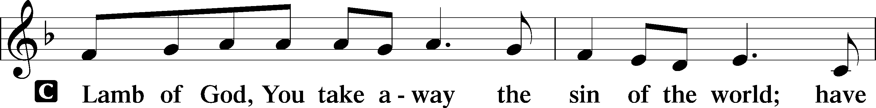
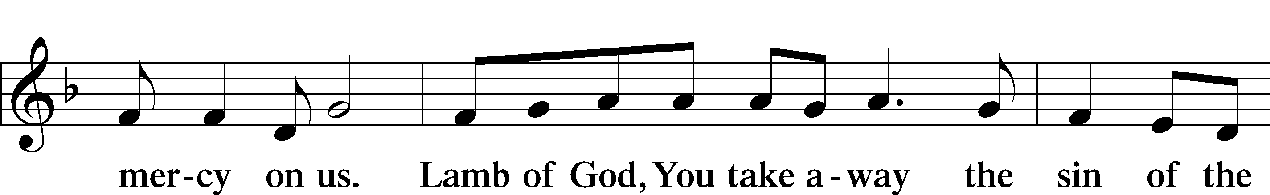
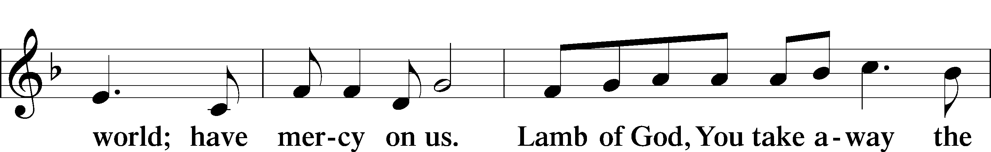
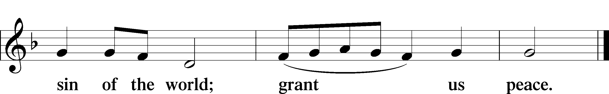

DISTRIBUTION HYMNS

“O Lord, How Shall I Meet You” [LSB 334] (1/4)

1 O Lord, how shall I meet You,
How welcome You aright?
Your people long to greet You,
My hope, my heart’s delight!
O kindle, Lord most holy,
Your lamp within my breast
To do in spirit lowly
All that may please You best.

2 Your Zion strews before You
Green boughs and fairest palms;
And I too will adore You
With joyous songs and psalms.
My heart shall bloom forever
For You with praises new
And from Your name shall never
Withhold the honor due.

3 I lay in fetters, groaning;
You came to set me free.
I stood, my shame bemoaning;
You came to honor me.
A glorious crown You give me,
A treasure safe on high
That will not fail or leave me
As earthly riches fly.

4 Love caused Your incarnation;
Love brought You down to me.
Your thirst for my salvation
Procured my liberty.
Oh, love beyond all telling,
That led You to embrace
In love, all love excelling,
Our lost and fallen race.

5 Sin’s debt, that fearful burden,
Cannot His love erase;
Your guilt the Lord will pardon
And cover by His grace.
He comes, for you procuring
The peace of sin forgiv’n,
His children thus securing
Eternal life in heav’n.

6 He comes to judge the nations,
A terror to His foes,
A light of consolations
And blessèd hope to those
Who love the Lord’s appearing.
O glorious Sun, now come,
Send forth Your beams so cheering,
And guide us safely home.
Text: Paul Gerhardt, 1607–76; tr. The Lutheran Hymnal, 1941, alt.
Text: Public domain

“Hark the Glad Sound” [LSB 349] (1/19)

1 Hark the glad sound! The Savior comes,
The Savior promised long;
Let ev’ry heart prepare a throne
And ev’ry voice a song.

2 He comes the pris’ners to release,
In Satan’s bondage held.
The gates of brass before Him burst,
The iron fetters yield.

3 He comes the broken heart to bind,
The bleeding soul to cure,
And with the treasures of His grace
To_enrich the humble poor.

4 Our glad hosannas, Prince of Peace,
Thy welcome shall proclaim,
And heav’n’s eternal arches ring
With Thy belovèd name.
Text: Philip Doddridge, 1702–51
Text: Public domain

“Come, Thou Precious Ransom, Come” [LSB 350] (1/20)

1 Come, Thou precious Ransom, come,
Only hope for sinful mortals!
Come, O Savior of the world!
Open are to Thee all portals.
Come, Thy beauty let us see;
Anxiously we wait for Thee.

2 Enter now my waiting heart,
Glorious King and Lord most holy.
Dwell in me and ne’er depart,
Though I am but poor and lowly.
Ah, what riches will be mine
When Thou art my guest divine!

3 My hosannas and my palms
Graciously receive, I pray Thee;
Evermore, as best I can,
Savior, I will homage pay Thee,
And in faith I will embrace,
Lord, Thy merit through Thy grace.

4 Hail! Hosanna, David’s Son!
Jesus, hear our supplication!
Let Thy kingdom, scepter, crown,
Bring us blessing and salvation,
That forever we may sing:
Hail! Hosanna to our King.
Text: Johann Gottfried Olearius, 1635–1711; tr. August Crull, 1845–1923, alt.
Text: Public domain

POST-COMMUNION THANKSGIVING Psalm 107:1

Pastor: Oh give thanks to the Lord, for He is good,
People: for His steadfast love endures forever.

Pastor: Lord Jesus, prepare us for that eternal Sabbath when You will rest in us, just as now You work in us. The rest that we shall enjoy will be Yours, just as the work that we now do is Your work done through us. But You, O Lord, are eternally at work and eternally at rest. It is not in time that You see or in time that You move or in time that You rest, yet You make what we see in time. You make time itself and the repose which comes when time ceases; for You live and reign with the Father and the Holy Spirit, one God, now and forever.
People: Amen.

BENEDICAMUS

Pastor: Let us bless the Lord.
People: Thanks be to God.

BENEDICTION Numbers 6:24–26

Pastor: The Lord bless you and keep you.
The Lord make His face shine on you and be gracious to you.
The Lord look upon you with favor and give you peace.
People: Amen.

HYMN “Once He Came in Blessing” [LSB 333] (1/3)

1 Once He came in blessing,
All our sins redressing;
Came in likeness lowly,
Son of God most holy;
Bore the cross to save us;
Hope and freedom gave us.

2 Now He gently leads us;
With Himself He feeds us
Precious food from heaven,
Pledge of peace here given,
Manna that will nourish
Souls that they may flourish.

3 Soon will come that hour
When with mighty power
Christ will come in splendor
And will judgment render,
With the faithful sharing
Joy beyond comparing.

4 Come, then, O Lord Jesus,
From our sins release us.
Keep our hearts believing,
That we, grace receiving,
Ever may confess You
Till in heav’n we bless You.
Text: Johann Horn, c. 1490–1547; (sts. 1, 4): tr. Catherine Winkworth, 1827–78, alt.; (sts. 2–3): tr. Lutheran Service Book, 2006
Text (sts. 1, 4): Public domain
Text (sts. 2–3): © 2006 Concordia Publishing House. Used by permission: LSB Hymn License no. 110004005

Creative Worship for the Lutheran Parish, Series A, Quarter 1.
Copyright © 2025 Concordia Publishing House. All rights reserved. Used by permission.

Acknowledgments
Unless otherwise indicated, Scripture quotations are from the ESV® Bible (The Holy Bible, English Standard Version®), copyright © 2001 by Crossway, a publishing ministry of Good News Publishers. Used by permission. All rights reserved.
Created by Lutheran Service Builder © 2025 Concordia Publishing House.

ANNOUNCEMENTS

BIRTHDAYS: Kathryn Goins 12/1; Chace Bickner 12/4; Erica Gilliland 12/4.

FIRST SUNDAY IN ADVENT: Today we begin a New Church Year. After the Divine Service we will clean the church and decorate for Christmas. A meal will be supplied. Ron is bringing pizza, Becky is bringing a salad and Mary, and I will bring Calzones.

MIDWEEK ADVENT SERVICES: They will begin on Wednesday December 3rd. We will have meal at 6:00 p.m. sponsored by the LWML. Our first meal will be baked potatoes. There is a sign-up sheet on the bulletin board going into the kitchen.

MIDWEEK ADVENT SERIES: The series this year is “All About Mary”. Week 1 “To Be a Part of God’s Salvation” Luke 1:26-38; Week 2 “God’s Plan takes Shape with Joseph” Matthew 1:18-25. Week 3 “A Leap of Joy from John and Mary” Luke 1:39-56.

FLOWERS ON THE ALTAR: If you would like to place flowers on the altar. There is a form on the back pew. Flowers help add to the beauty of the Service.

LWML CHRISTMAS TREE: This year the LWML Christmas Tree is asking for donations for La Luz Women’s Center. They need baby clothes up to age 3. All new coats, gloves, booties, socks, diapers especially 4-5, cash donations are also appreciated.

VISITORS’ CARDS: In the pew racks we have visitor cards. We would
like our visitors to fill out the bottom portion and place it in the offering plate.

UP AND COMING EVENTS:

First Sunday in Advent, November 30. After the Divine Service we will Decorate and Clean the church. A meal will be provided.
First Midweek Advent Dinner and Devotion: December 3. Dinner at 6:00 p.m. Baked Potato.
Second Midweek Advent Dinner and Devotion: December 10. Dinner at 6:00 p.m. Mexican.
Voter’s Meeting Sunday December 14 after the Divine Service, Meal After the meeting
Third Midweek Advent Dinner and Devotion: December 17, Dinner at 6:00 p.m. Italian.
LWML Sponsored Christmas Meal for the Congregation – All are invited after the Divine Service – Sunday December 21.
Christmas Eve Service with Holy Communion December 24 at 7:00 p.m.
Sunday December 28 will be Choose your Hymn Sunday.

SUNDAY SCHOOL & BIBLE CLASS----------8:45 A.M.
DIVINE SERVICE -------------------------10:00 A.M.
COMMUNION--------1st, 2nd, 3rd and 5th Sundays
VACANCY PASTOR----------------Gary A. Bickner
OFFICE PHONE----------------------------863-3375
HOME PHONE------------------------505-399-8387
E-MAIL…………………………tlcgallup@gmail.com
WEBSITE………..……trinitylutherangallup.com
SUMMER WORSHIP HOURS-------------9:00 a.m.
(Memorial Weekend through and including Labor Day Weekend)
BIBLE STUDIES AS ADVERTISED

